**COMMON ERRORS THAT OCCUR WHEN WORKING WITH ANSIBLE AND HOW TO SOLVE THEM**

**A: When running playbook.**

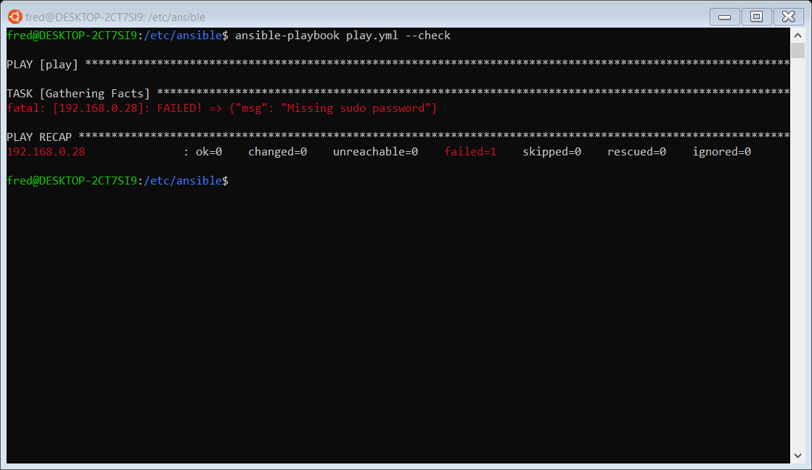**Main error: fatal: [target_name]: FAILED! => {"msg": "Incorrect sudo password"}**

**SOLUTION**

**T**his error appears when **user** on the **node (server)** you are trying to deploy your code does not have **root** privilege.

In this case

**Step 1**. **ssh** into the **node** by *ssh user_name@target*

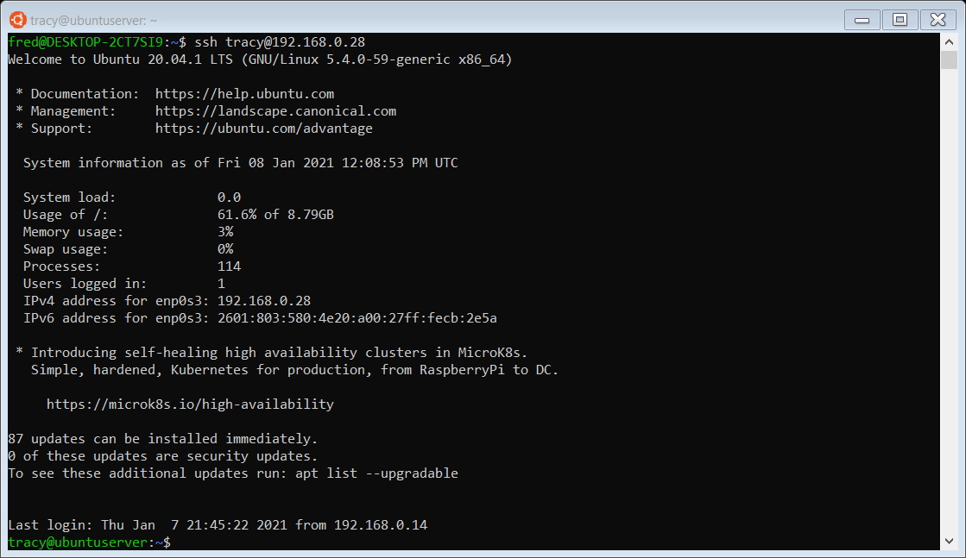 **Great! you are in the node**

**Step 2.** While in the **node**, do *sudo su* to gain *root* privilege.

If “*[sudo] password for tracy:”*  prompted, put password for user “*tracy”*

**Step 3. Do”*visudo*” to add *tracy* to root privilege.**

Under #Allow members of group sudo to execute any command

type “user_name ALL=(ALL:ALL) NOPASSWD: ALL” to give root privilege.

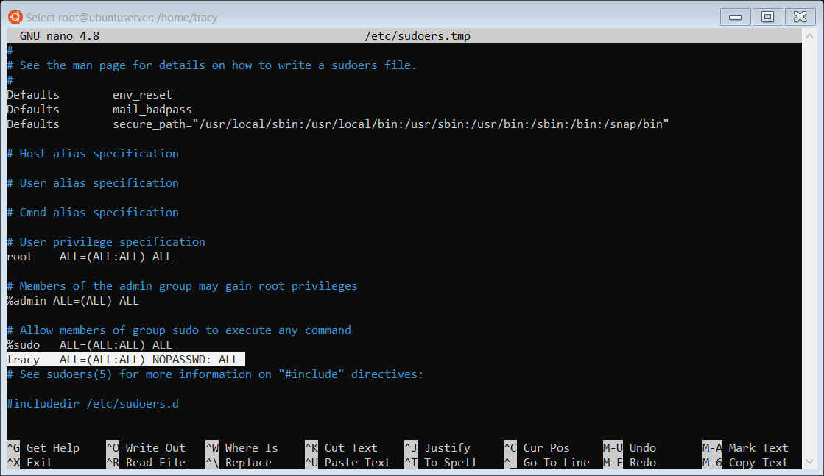

**Step 4. Let’s try to deploy the code again**

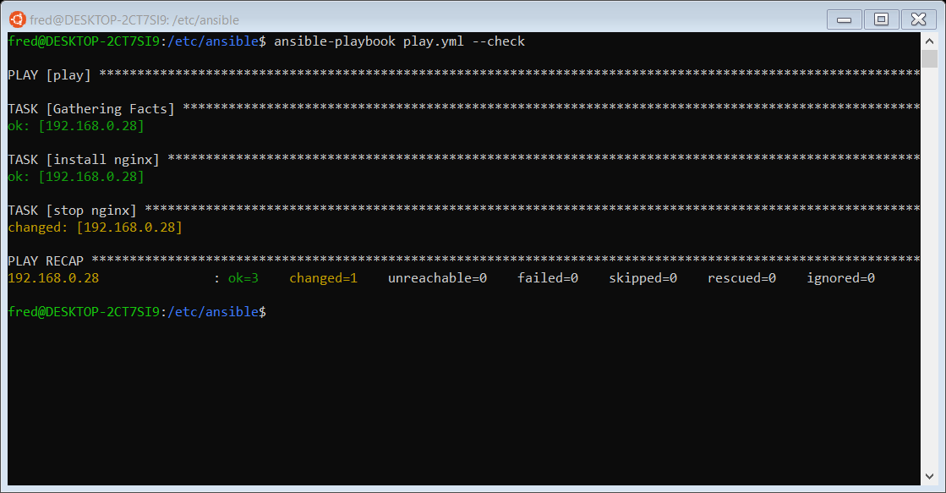

**Now everything looks great.**

**Congrations!!!**

**B: when trying to copy the public key to the node.**

**Command: *ssh-copy-id user_name@target***

**Main error: Permission denied (publickey)**

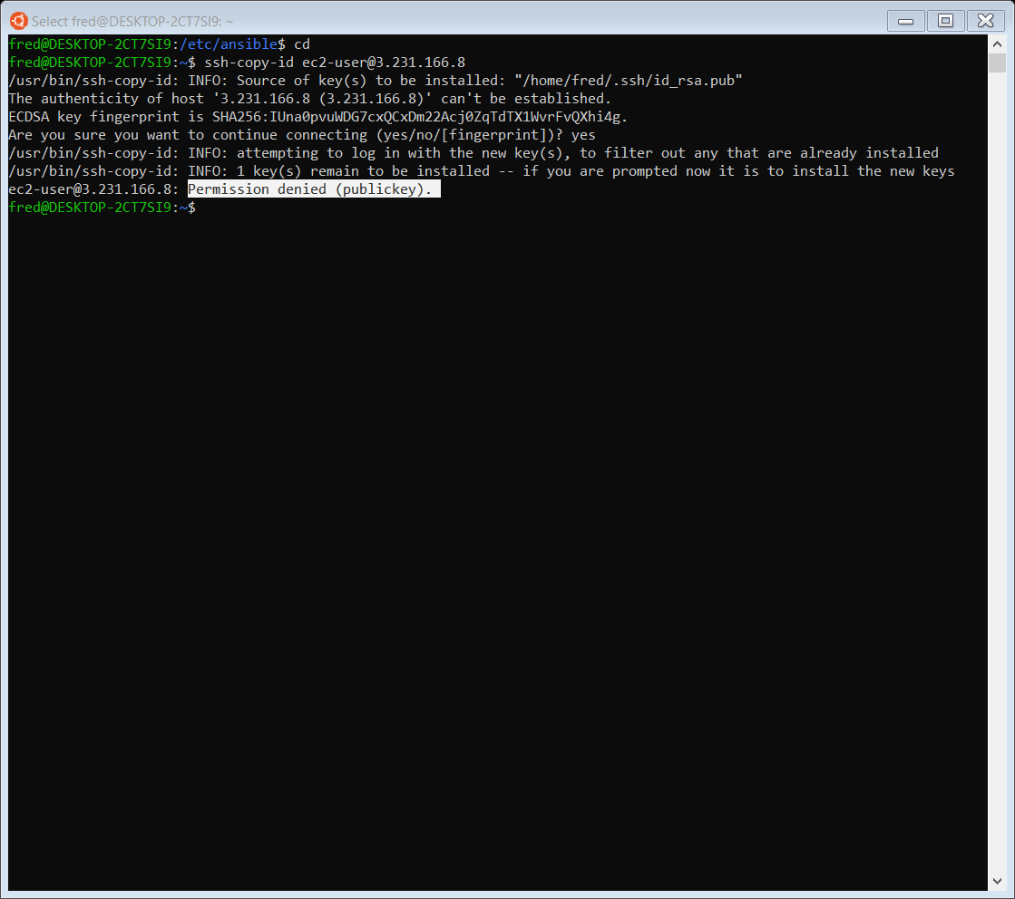

**SOLUTION**

**Step:** log into the node

Do sudo su to switch privilege to root.

move to ssh directory by typing cd /etc/ssh

while in ssh directory nano into sshd_config

under #PermissionAuthentication

change **PasswordAuthentication no** to **PasswordAuthentication yes**

**Now to refresh ssh directory depends on the Linux distro you are using**

* **For ubuntu type -------🡪 *service ssh restart***

OR

* **For any other Linux distro, type ------**🡪 service *sshd restart*

**Step:** Go back and run the *ssh-copy-id user@target* commandagain*.*

Everything looks great, but password is needed to authenticate the user.

**Step:** Create the *user*’s password

Go back to the **note and type *sudo passwd user_name.***

**Enter your preferred password.**

**Now, go back and enter the password you just created to authenticate the user.**

**Ok, Let’s try logging into the machine, with: "ssh 'ubuntu@75.101.222.125'"**

**Now we’ve successfully authenticated ssh connection between the two machines.**

**Congratulations!!**